***Year 9 Framing and Composition Response Task***

**Shot 1**

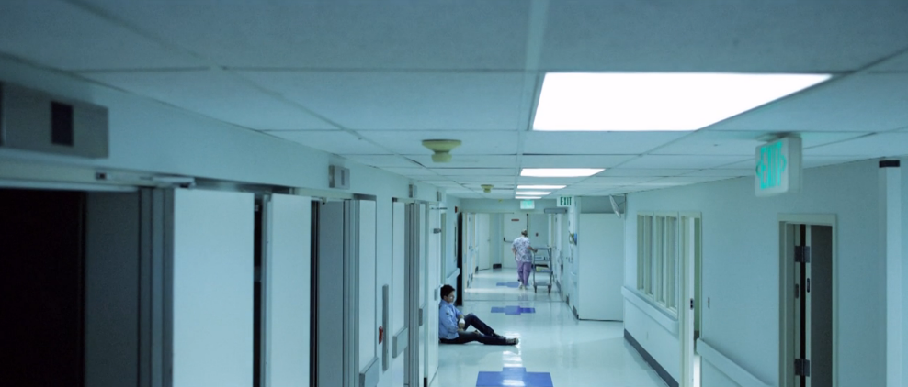

Shot Size:

Shot Angle:

Camera Movement:

Explain the feeling created through the framing, composition & movement:

**Shot 2**



Shot Size:

Shot Angle:

Camera Movement:

Explain the feeling created through the framing, composition & movement:

**Shot 3**



Shot Size:

Shot Angle:

Camera Movement:

Explain the feeling created through the framing, composition & movement:

**Shot 4**



Shot Size:

Shot Angle:

Camera Movement:

Explain the feeling created through the framing, composition & movement:

**Shot 5**

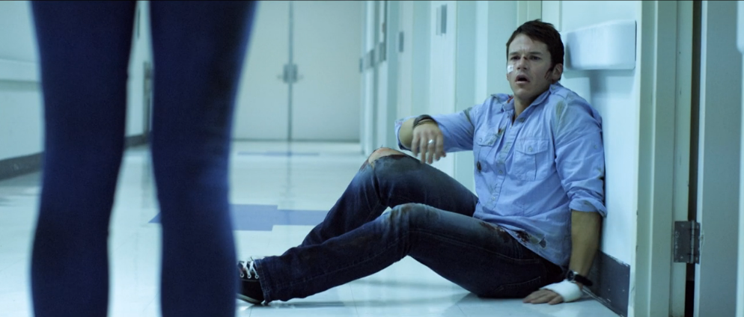

Shot Size:

Shot Angle:

Camera Movement:

Explain the feeling created through the framing, composition & movement:

**Shot 6**

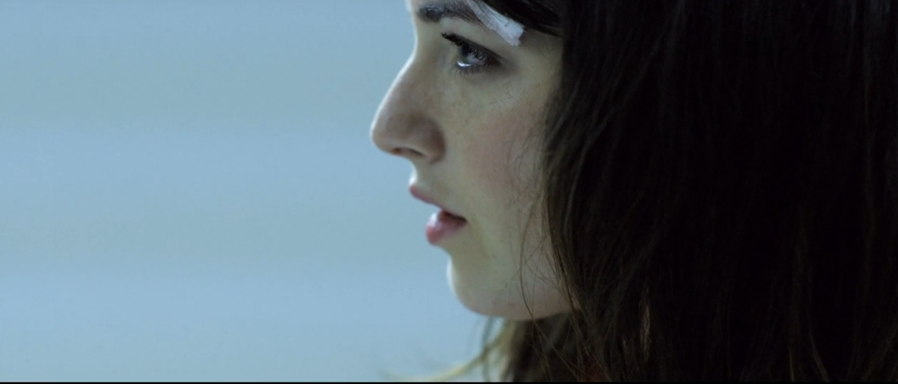

Shot Size:

Shot Angle:

Camera Movement:

Explain the feeling created through the framing, composition & movement: