Media, Year 10 (Sem 1) **TASK 3: Webpage Campaign**

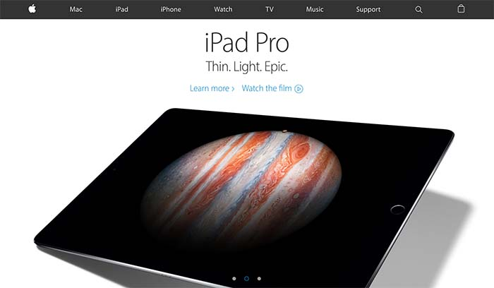

**TASK DESCRIPTION:**

Students will be designing a landing webpage for their company from Task 2 and uploading the completed advertisement.

The webpage will need to be dynamic, eye-catching and produced to a high standard following current design principles (typography, colour scheme, use of images, usability, navigation)

Students will be using Adobe Muse as the design platform.

**TASK REQUIREMENTS:**

1. Students will design a landing page for their company using Adobe Muse
2. Students will upload their completed advertisement to their site. Videos can be uploaded using YouTube or Vimeo (you will have to upload your advertisement to these sites) or via creating an .oem file using Adobe Edge Animate.   
     
   *Your teacher will assist you will uploading via Edge Animate.*

**TASK 3: Webpage Campaign | MARKING KEY**

|  |  |
| --- | --- |
| CRITERIA | Result |
| Media Skills: Pre-Planning | |
| Webpage planning is complete identifying current design principles and the attributes of the specific target audience in detail. | 5 |
| Webpage planning is complete identifying some of the design principles and attributes of the specific target audience. | 4 |
| Webpage planning is complete identifying the design principles and target audience. | 3 |
| Webpage planning shows little thought and is largely incomplete. | 2 |
| Webpage planning shows no thought and is incomplete. | 1 |
| **Media Skills:** Use of Software and Technology | |
| Webpage is exceptionally designed and contains all of the attributes of a professional webpage. | 9-10 |
| Webpage is well designed and contains all of the attributes of a professional webpage. | 7/8 |
| Webpage is well designed and contains most of the attributes of a professional webpage. | 5/6 |
| Webpage contains some of the relevant attributes of a professional webpage | 3/4 |
| Webpage does not contain the relevant attributes of a professional webpage | 1/2 |