Media, Year 10 (Sem 1) **TASK 1: Advertising Campaign Response**

Due Date: Week 3

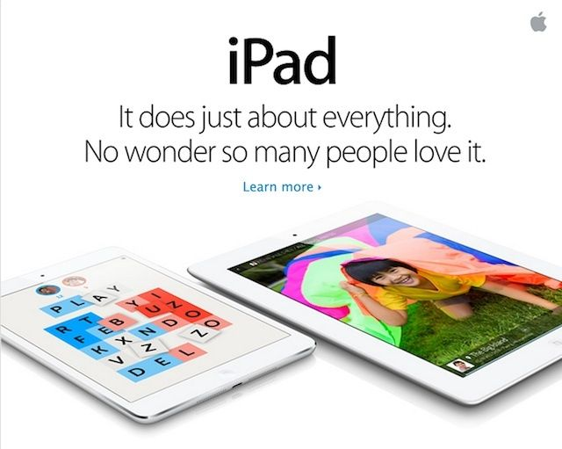

**TASK DESCRIPTION:**

**Part A:** Research.Students will choose from 1 of the following companies to research and analyse the history of its advertising campaigns.

Companies to choose from:

(a) Coke-Cola

(b) Apple

(c) Nike

(d) McDonalds

**Part B:** Response.  
Write a 1-2 page response based on your findings identifying the following:

a) What is the intended target audience? And has that changed over the years?

b) What advertising codes and conventions are used in their campaigns?  
- Symbols (objects, setting, colour, clothing, body language)  
- Written (captions, phrases, style, titles)  
- Technical (camera angle, lighting, editing)  
  
c) How do the advertising codes and conventions used in each campaign construct meaning about stereotypes?

d) How have changes in technology affected the way advertising campaigns are constructed?

e) Do you think the campaigns were successful? If so, how and why?

**TASK REQUIREMENTS:**

1. Research 1 of the 4 companies looking at the history of their advertising campaigns.
2. Write a 1-2 page response looking at the different advertising conventions, target audience, stereotypes and technology.

**TASK 1: Advertising Campaign Response | MARKING KEY**

|  |  |
| --- | --- |
| CRITERIA | Result |
| Media Responses: Understanding of Media Concepts | |
| Student has written with a strong understanding of media concepts, and is able to analyse the different campaign features and meanings. | 9-10 |
| Student has written with an understanding of media concepts, and is able to analyse the different campaign features. | 7/8 |
| Student has shown a general understanding of most of the media concepts, and is able to discuss the advertising campaigns. | 5/6 |
| Student has shown a general knowledge of the media concepts, and is able to discuss some of the features of the advertising campaigns. | 3/4 |
| Student does not show understanding of many of the media concepts. | 1/2 |
| **Media Ideas:** Use of Media Terminology | |
| Questions answered correctly and in detail. A comprehensive use of media terminology in the response. | 5 |
| Questions answered mostly correctly. Appropriate media terminology used in the response. | 4 |
| Questions answered mostly correctly. Media terminology used occasionally. | 3 |
| Questions answered minimally or mostly incorrectly. Minimal use of media terminology. | 2 |
| Very little written. Use of casual language. | 1 |