Check your understanding
See if you can identify the components 1–13 that are numbered in the photo below. Then check the Feedback given on the next page.
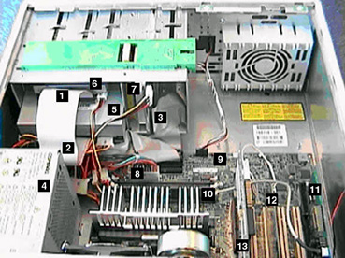
Components inside the system unit
1
2
3
4
5
6
7
8
9
10
11
12
13
Feedback
1 Signal/data cable of the floppy disk drive
2 Signal/data cable of the CDROM drive
3 Signal/data cable of the hard disk drive
4 Power supply unit
5 CDROM
6 Floppy disk drive
7 Hard disk drive
8 Power cable for the motherboard
9 Motherboard
10 Memory chips (RAM)
11 Sound card
12 Network interface card
13 Video adapter card

