Check your understanding
See if you can identify the components 8–13 that are numbered in the photo below.
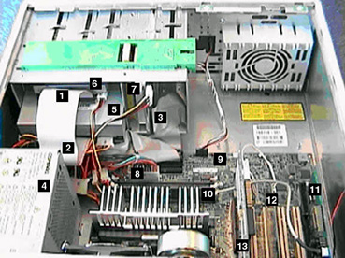
Components inside the system unit

8
9
10
11
12
13

Feedback
8 Power cable for the motherboard
9 Motherboard
10 Memory chips (RAM)
11 Sound card
12 Network interface card
13 Video adapter card

